- Requirement

Average volume of goods : 500x300x500 mm
Scissor lift base : 600x400x100 mm

Travel distance: 400 mm (0.4 m)
Slide plate : 50 mm
Screw end : 50 mm
Screw length : 500mm

Axial load : 35 Kg
Linear speed : 26.7 mm/sec (0.0267 m/sec)

Linear accuracy: 0.5 mm (How much travel accuracy is needed ball screw itself)
Travel tolerance = 400 ± 0.5 mm

- Ball screw Calculation

- Accuracy Grade
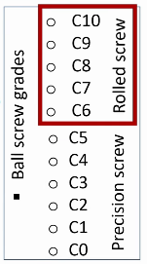
- Amount of error in linear travel distance.
- It is divided into C0 to C10 as we will go lower side we will get more precise accuracy
- From C0 to C5 grid is the precision ground ball screw grid and above C5 is Rolled ball screw.
- The recommended accuracy grade for machine applications is shown in table ??. This is the reference chart for selecting the suitable ball screws in different application.
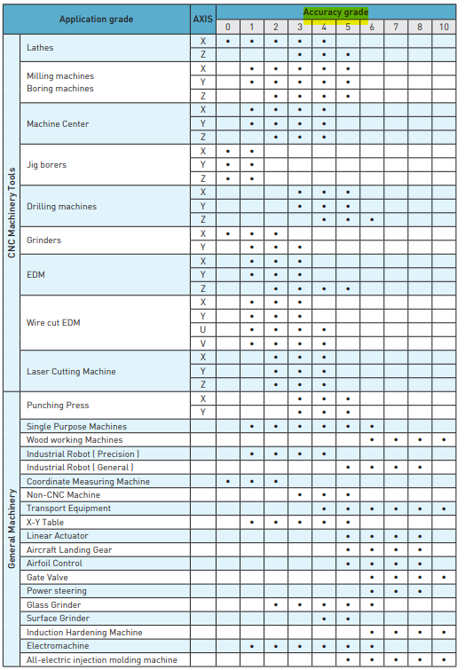

Table ?? recommended accuracy grade for machine applications

Considering the accuracy grade is C7 / rolled ball screw

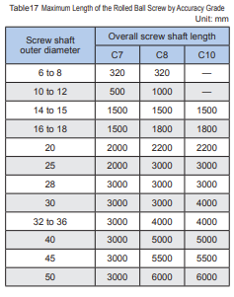
Table17 shows the manufacturing limit lengths of rolled Ball Screws by accuracy grades

As the maximum length of the screw is 500 mm, Then the outer diameter of screw >= 10 mm

- Lead selection

Lead = V_{max} linear speed (mm/s) * 60 / N_{max} rotational speed of motor (RPM)

- length of ball screw = 500 mm
- speed of the motor
- by using stepper motor then the maximum speed is 1000 RPM
then,
lead ≥ 26.7*60/1000 ≥ 1.6 mm
considering lead = 4 mm

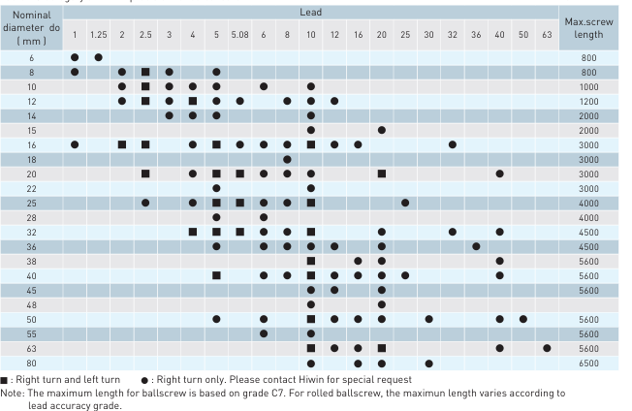
- Ball screw diameter

As lead = 4 mm
Then select the outer diameter (D) = 12 mm

And the minor diameter (d) = 9.7 mm

- Maximum Axial load on ball screw

Maximum load = 35 Kg
Axial force = load * g = 35 Kg * 9.81 m/sec² = 343.35 N

Then Static load = 343.35 N

Dynamic load = F_{ax} + mass * a + F_{ax} * µ
F_{ax} = Axial load
µ = coefficient of fraction

from equation motion : V² = V₀² + 2ad
then, a = V² / 2d = 0.0267² / 2(0.4) = 8.9*10⁻⁴ m/sec²

dynamic load (maximum load) = 588.6 + 60 * 8.9*10⁻⁴ + 0.6 * 588.6 = 549.39 N

Permissible Axial Load

P = 0.5(η₁ π² E I)/ l_{a}² = 10⁴(η₂ d⁴)/ l_{a}²
P 1 : Buckling load (N)
ℓa : Distance between two mounting surfaces (mm)
E : Young’s modulus (2.06×10⁵ N/mm² )
I : Minimum geometrical moment of inertia of the shaft (mm⁴ )
d1: screw-shaft thread minor diameter (mm)
η1 , η2 =Factor according to the mounting method
Fixed - supported η1 =2 η2 =10

P = 10⁴ (10 * 9.7⁴) / 500² = 3541.17 N

Maximum load < permissible load

Selection is Approved

- Maximum Rotational speed RPM
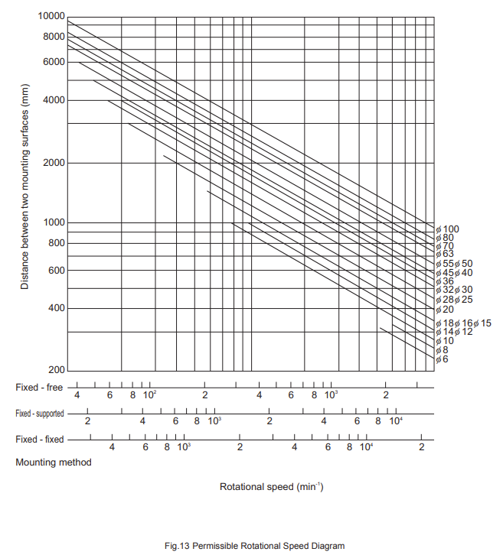
N_{max} = (V_{max} * 60) / lead

N_{max} = (26.7 * 60) / 4 = 400.5 RPM

Permissible Rotational Speed

N_{p} = 6000 RPM

Then,
Max Rotational speed > Permissible Speed

Selection is approved

- Motor selection

- required Torque :-
Max load (L) = 589.3912 N
Ball screw lead (p) = 5 mm

Torque (T) = [L (N) * p (m)] / 2π * η
η = ball screw efficiency (0.9 to 0.95)
T = 0.389 Nm

- required speed
N_{max} = 400.5 rpm

The suitable motor is stepper motor NEMA 17
SFU 1204 [D= 12mm, L= 4mm]

